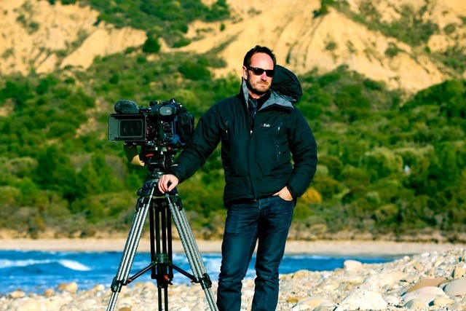Sennheiser enables Andy Taylor ACS to go beyond cinematography to become a “one-man band”
The award-winning Australian cinematographer trusts Sennheiser’s EW-DP, MKH 416 and MKH 8060 to ensure high quality audio for his work across Netflix, National Geographic, Disney+, CBS 60 Minutes (USA), BBC Studios, and more.

Sydney, Australia, 16 November 2023 – Legendary Australian cinematographer, Andy Taylor ACS has been working with Sennheiser microphones for more than three decades, having travelled to over 110 countries whilst relying on the manufacturer’s esteemed audio quality. Although primarily a cinematographer, the nature of Taylor’s work often requires him to operate and record his own audio, making Sennheiser’s easy-to-use and reliable recording solutions a constant in his arsenal.

Andy was first introduced to Sennheiser microphones in 1986 when he began his career as a trainee studio camera operator for the Australian Broadcasting Corporation (ABC). Working on Australia’s iconic children’s programs Mr. Squiggle and Playschool is where you might find Andy operating a boom pole complete with an MKH 416. During his 25 years as a cinematographer at the ABC, Andy recalls that crews in the highly regarded cine-camera department were all issued MKH 416 microphones as part of each field kit, and it’s been his go-to microphone ever since.

“I always carry two MKH 416 microphones in my kit. My work is unpredictable, so I like to be prepared for anything that’s thrown at me, including capturing sound on my own when required, whether that is recording a presenter, reporter, a press conference, dialogue or just background noise,” shares Andy, “because a large part of my work is interview based, I need the best gear that is super dependable. The 416 can handle difficult filming and reporting conditions without any issues, I’ve used them all day every day for the past 35 years when operating as a one-man band – they are bullet proof!” As his go-to boom microphone, Andy used the MKH 416 when filming and recording interviews such as those seen in the Netflix and ABC-TV documentary series ‘Exposed: The Ghost Train Fire’ which saw Andy win a Walkley Award, Kennedy Award, and the Gold Award for Documentaries at the ACS Awards – some of Australia’s most prestigious cinematography accolades.

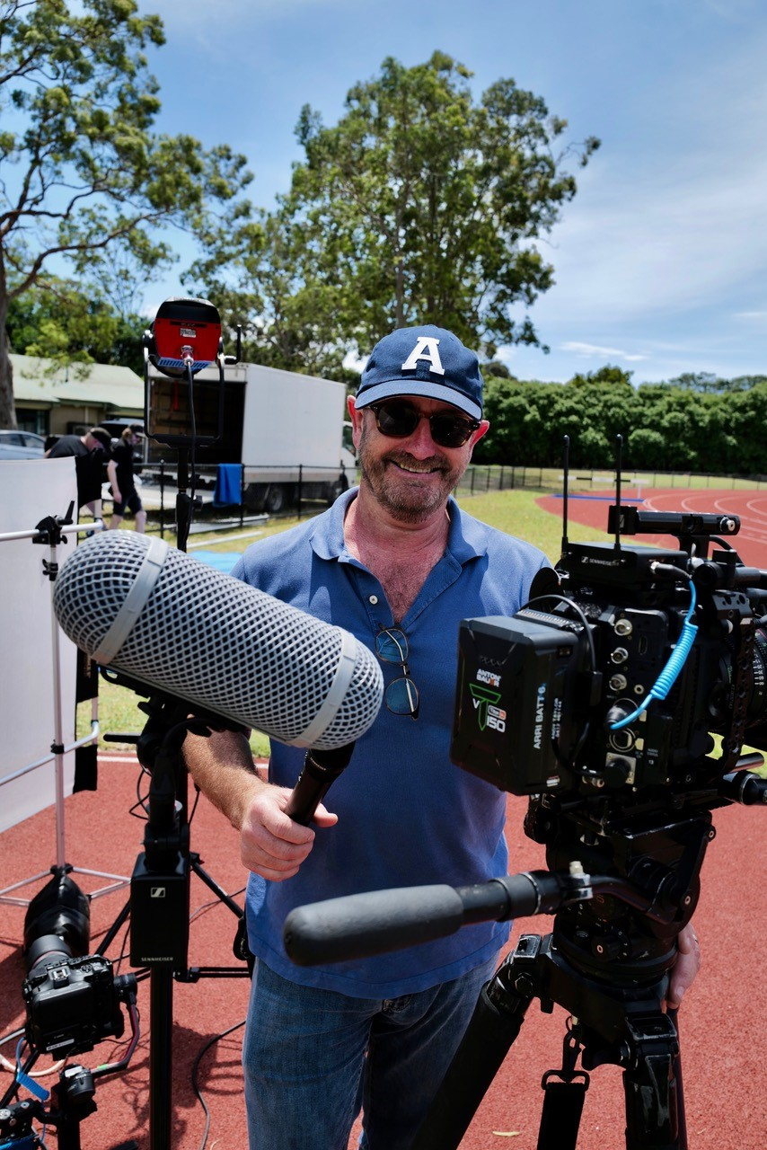 | Andy Taylor with his Sennheiser audio rig, featuring the EW-DP Wireless Microphone System, MKH 8060, SKP Wireless Plug-On Transmitter and more.

Andy reflects on the EW-DP, a recently launched portable UHF wireless system in Sennheiser’s Evolution Wireless Digital family of solutions that enables him to seamlessly connect straight to his camera, allowing for flexibility to move around and not trip over audio cables. The EW-DP series not only simplifies his setup with industry-leading audio quality, but also offers Bluetooth synchronization and system control via the Smart Assist app, adding versatility, and allowing professionals like Andy to focus on their creative work. Even better, as Andy explains “one of the great things about this new system is that the batteries last all day, in both the transmitters and the receivers. It’s a lifesaver because working with AA batteries in some other radio microphones, you’d be lucky to get an hour, so a good battery system is crucial.” The EW-DP impresses with its extended battery life, offering a choice of power sources, including lithium-ion rechargeable batteries, standard AA batteries, or external charging via USB-C. Intelligent battery management displays the exact operating time when using the included BA70, offering extended life up to 12 hours on the transmitters and up to 7 hours on the receiver.

The simple integration of the EW-DP with any camera makes it an ideal partner to streamline audio workflow. “The form factor of the receivers and being able to clip onto the magnetic mounting bracket system of the camera is quick and easy. There's a variety of connectors, (either 3.5 mm or XLR), so straight into whichever camera system you're using.” Andy describes the EW-DP, expressing enthusiasm for the soon-to-be-released SKP plug-on transmitter meaning Andy can wirelessly connect the MKH 416, or MKH 8060 (the latest addition to his collection), and operate completely without cables. Currently, in his day-to-day work, Andy is a fan of mounting the MKH 8060 on his camera as a top mic, a setup which he puts as “slightly overkill, but it just means I have a compact, quality mic with me all the time, just in-case! It’s the go-to mic of many of my professional sound recordist mates.”

“There are lots of other brands out there, but quality and reliability are critical. To me, it's all about having durable gear from a respected and trusted brand that cares about customer service, knowing that the batteries will last forever and that you’re getting great quality audio every time - without drop-outs or interference, equipment that can take the knocks that won’t let me down, even in humid or dusty environments.” Making the most of the EW-DP Andy can quickly and easily connect it to either his Canon Cinema EOS C500 or Arri ALEXA Mini LF via the XLR, alternatively use his Canon C70 or R5C via the 3.5mm connector. Describing this set-up as “a saviour, especially with the Arri as I have now permanently attached one of the mounting brackets to each camera cage and I just clip the receiver onto the bracket with the magnets, plug it in and away she goes!”

Andy’s remarkable list of credits has seen him work on some of Australia’s most respected and influential programs. Having spent 25 years with the ABC, Andy is mainly recognised for his time in some of the ABC’s foreign bureaux and on the award-winning current affairs documentary program Four Corners, which is Australia’s longest running TV show, where he filmed 98 complete episodes over 12 years. Andy later moved onto film for 60 Minutes where he would spend weeks at a time travelling overseas filming stories covering every genre: human interest, true crime, wildlife and adventure, science, politics, celebrity profiles, wars, civil unrest, and more, with the country’s most respected journalists.

Today, Andy specialises in filming documentaries, commercial productions, network promotions, television commercials, dramatised re-enactments, and multi-camera interviews. These days Andy often operates solo as a “one-man band” shooting, lighting, and recording his own audio.

When Andy started working as a freelancer, to help save time on the road he encouraged his wife Jo, a professional film and TV make-up artist, to assist him setting up the sound on shoots. “I often film with three or four cameras, so I taught her how to help me with very basic audio, and now six years later she’s travelling the world as a professional sound recordist, she's mastered the dark art of radio-mic placement, and become a crucial part of our documentary crew,” shares Andy.

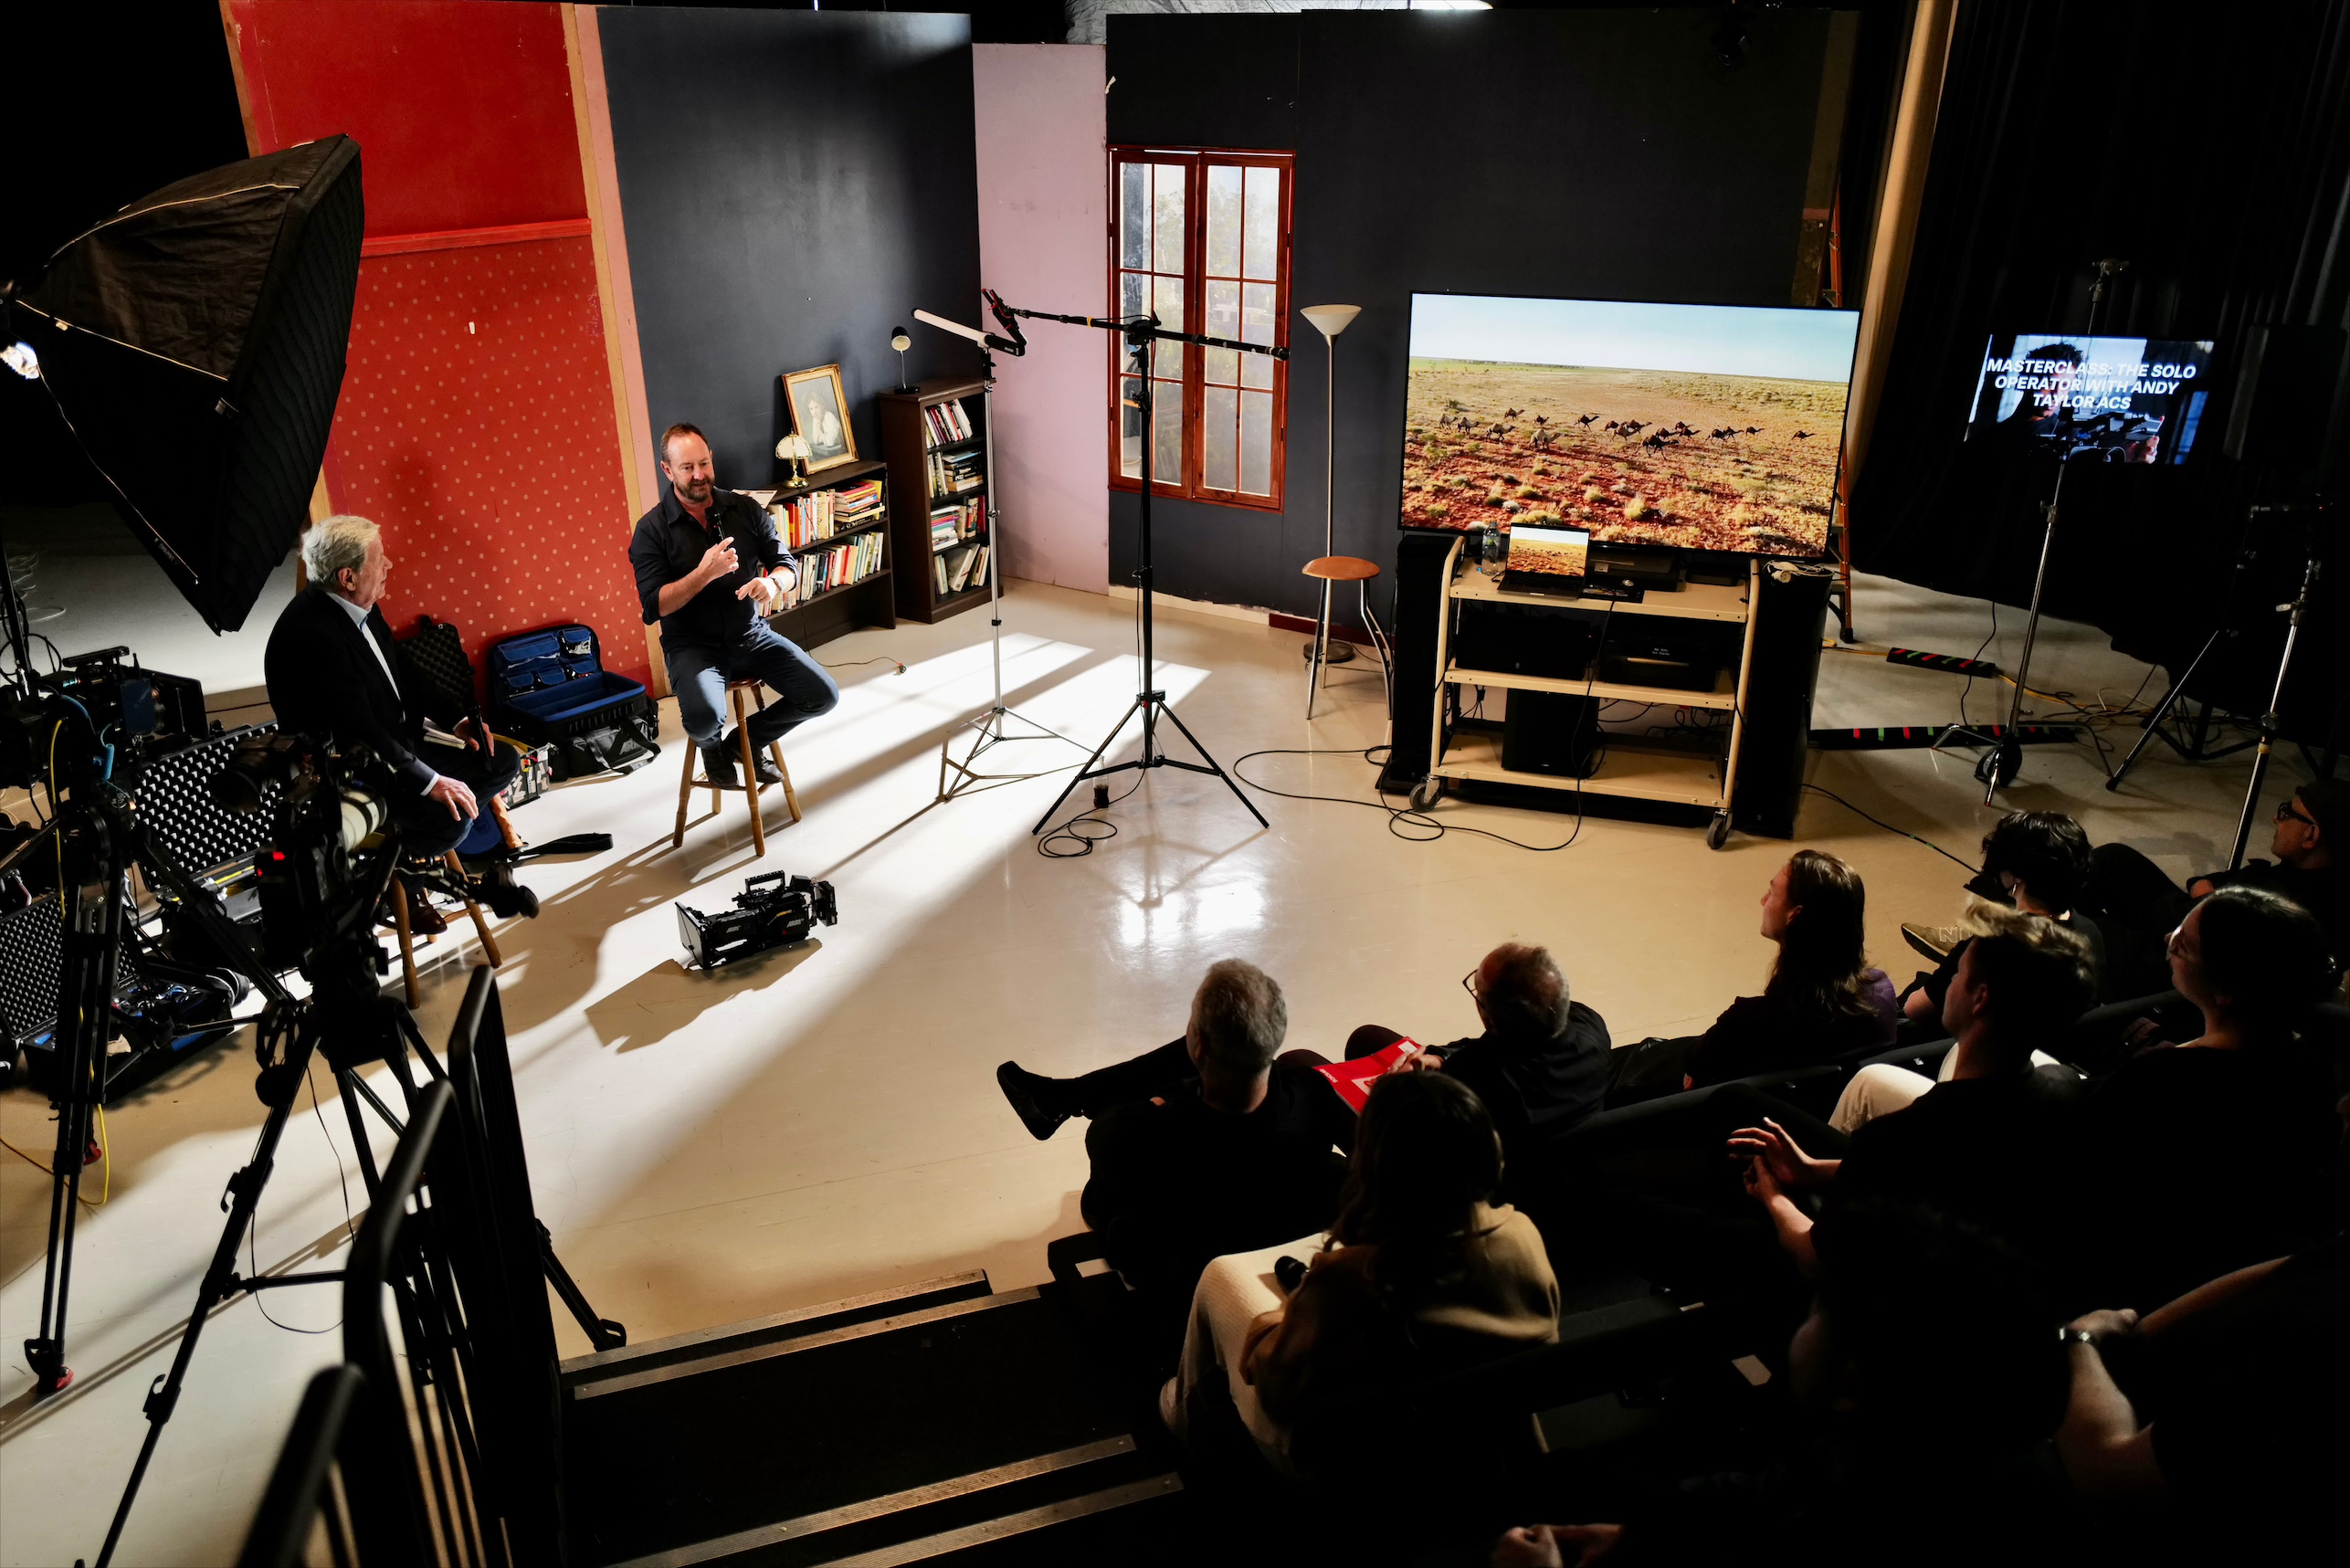
Andy Taylor ACS and Ray Martin AM talk to Macquarie University film students about their careers, equipment, and the importance of the right technology for a successful shoot during the August 2023 ‘Solo Operator’ Masterclass.

Extending Andy’s relationship with Sennheiser beyond his audio equipment, in August 2023 he hosted the ‘Solo Operator’ Masterclass at Macquarie University in partnership with the brand. Tapping into both Sennheiser and Andy’s passion for educating and equipping the next generation of filmmakers, the class of 50 film students got to hear from Andy about his thought process when preparing for a shoot, the best routes into filmmaking, choosing the right technology for a successful shoot and the importance of using content to tell a story in a creative way. Students also enjoyed a Q&A moderated by acclaimed television journalist Ray Martin AM. University representatives and students both called out how valuable the session was in upskilling younger generations and understanding the nuances of cinematography.

“The Masterclass at Macquarie University was an extension of Sennheiser’s commitment to create the future of audio by supporting the next generation of filmmakers. We are proud to have partnered with such esteemed professionals as Andy Taylor and Ray Martin to bring real world experiences and expertise to these emerging filmmakers,” says Ruth Bailey, Pro Audio Marketing Manager, Sennheiser ANZ, “We hope that the Masterclass empowered students in their creative workflows while inspiring them to equip themselves for success in their careers.”

Most recently Andy has worked on an incredible line-up of content with his talents gracing the hit Netflix series Selling Sunset, an upcoming documentary on UK pop star Ellie Goulding, documentaries for Tourism Australia and Queensland Tourism in the outback and feature documentaries in Asia, Europe, and the United States. With his trusty MHK 416 that he’s used for over 35 years, the MK 8060 and the latest addition of the EW-DP, Andy is eager to continue incorporating these high-quality audio solutions into his future endeavours.

To see more of Andy’s work or to learn more about his illustrious career visit his website or Instagram.

About Sennheiser
We live and breathe audio. We are driven by the passion to create audio solutions that make a difference. Building the future of audio and bringing remarkable sound experiences to our customers – this is what the Sennheiser brand has stood for since more than 75 years. While professional audio solutions such as microphones, conference systems, streaming technologies and monitoring systems are part of the business of Sennheiser electronic GmbH & Co. KG, the business with consumer devices such as headphones, soundbars and speech-enhanced hearables is operated by Sonova Holding AG under the license of Sennheiser.
www.sennheiser.com
www.sennheiser-hearing.com

Local Press Contact
Daniella Kohan
daniella.kohan@sennheiser.com
+1 (860) 222-4226

